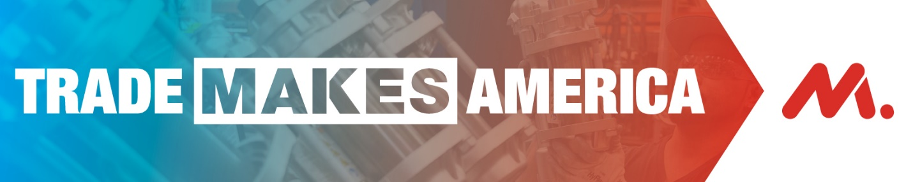

Colleagues,

The continued success of manufacturing depends on all of us using our collective voice to urge Congress to pass the USMCA, our new trade agreement with Canada and Mexico. More than 2 million manufacturing jobs depend on trade, and Congress needs to hear loudly and clearly why USMCA is a big deal for our industry.

That’s why I’m asking all of you to take action. Click here NOW to tell Congress why passing USMCA is so important to our company.

Trade is important for Americans, helping us sell more of what we make here to customers around the world. This agreement strengthens and modernizes America’s innovation engine while leveling the playing field by expanding access to Canada and Mexico.

Again, that’s why I hope you’ll take 60 seconds to click this link and tell Congress to pass USMCA today.

To learn more about the USMCA, please check out this information sheet.

Thank you for your support,

[NAME]

