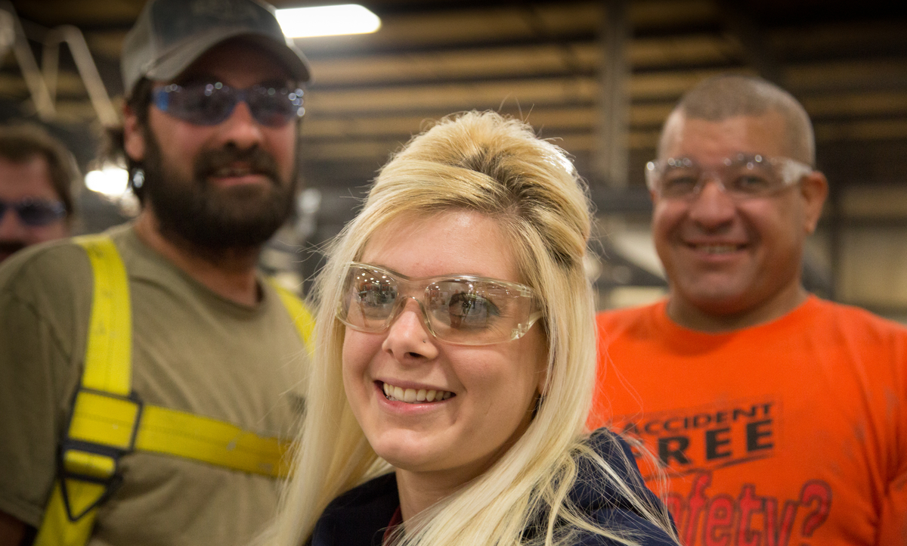
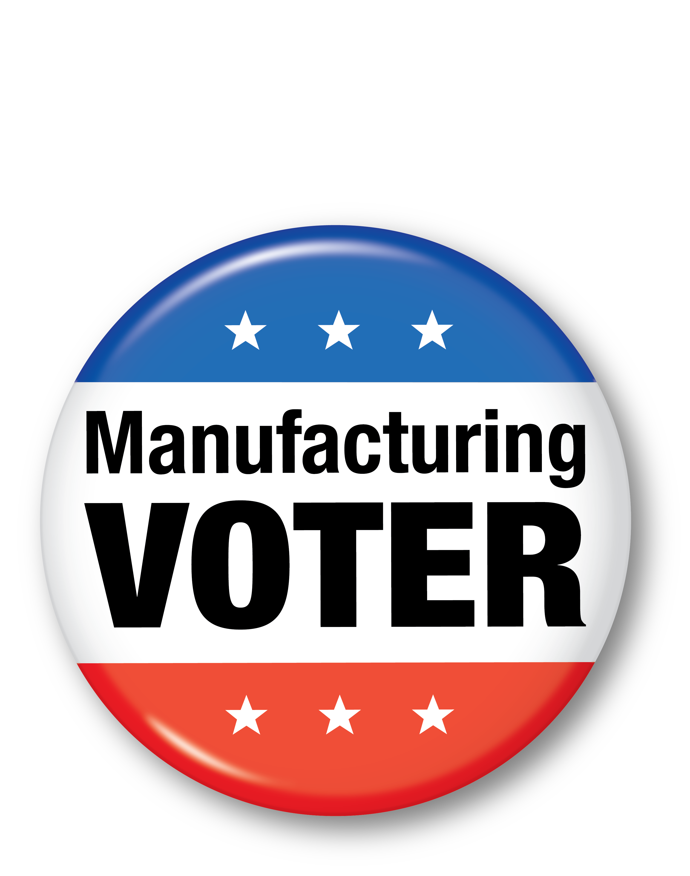

Election Day 2016 is right around the corner! A lot is at stake for manufacturing voters. Make your voice heard on Election Day!
Your polling location and voter registration information can be found by visiting www.nam.org/electioncenter.

Your vote counts.
In 2016, be a Manufacturing Voter!

Your Company logo

